**Automation Test Engineer Capstone**

API testing using Postman

1. **Sending a POST request to create a user, using Bearer Token.**

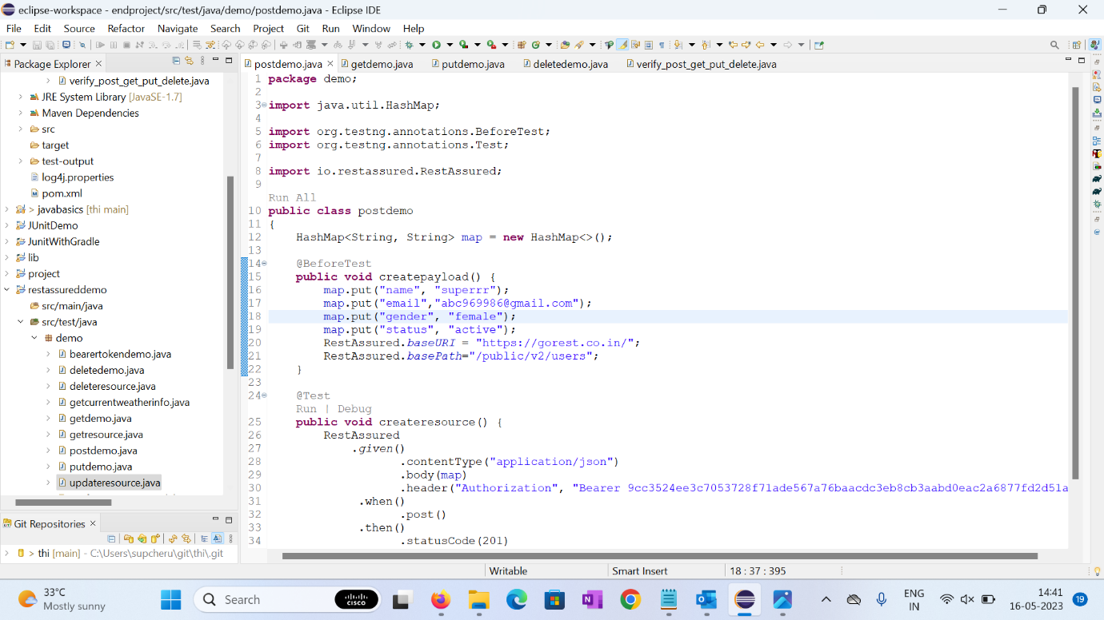

1. **Console output of** **Sending a POST request to create a user, using Bearer Token.**

1. **Sending a GET request to verify the user has been created, using Bearer Token.**

1. **Console output of Sending a GET request to verify the user has been created, using Bearer Token.**

1. **Updating the same user using PUT request, using Bearer Token.**

1. **Console output of Updating the same user using PUT request, using Bearer Token.**

1. **Deleting the above user using Delete request.**

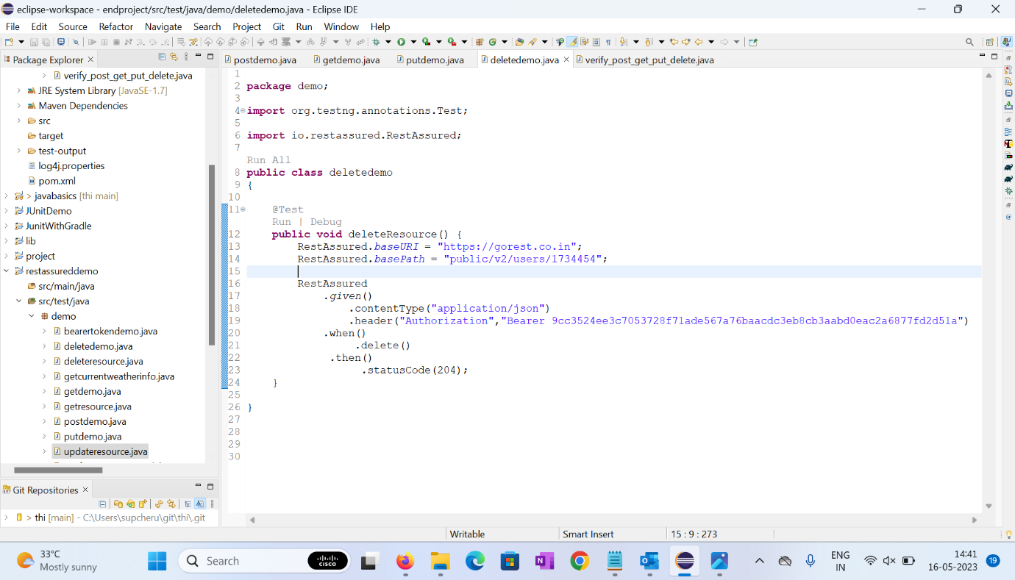

1. **Console output of Deleting the above user using Delete request.**

1. **Verifying the post, get, update and delete request of the above user using Bearer Token.**

1. **Console output of Verifying the post, get, update and delete request of the above user using Bearer Token.**

